PRINT AND SUBMIT WITH WEBSITE

Name:

Class:

Project Title:

Submission Date:

1. Introduction

2. Research Part A:

Research of existing ePortfolio website layouts:

Add url of the website here and screen grab
http://www.eportfolio.com/

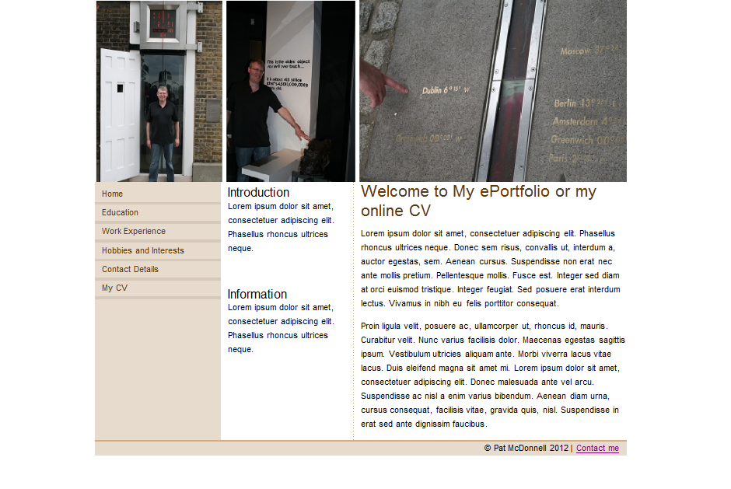

Comments: Simple layout & subtle use of colour – easy to distinguish main sections ,navigation, header, footer and contact details

3. Research Part B:

Web Design I Like

Add url of the website here and screen grab
http://www.propertypriceregister.ie/

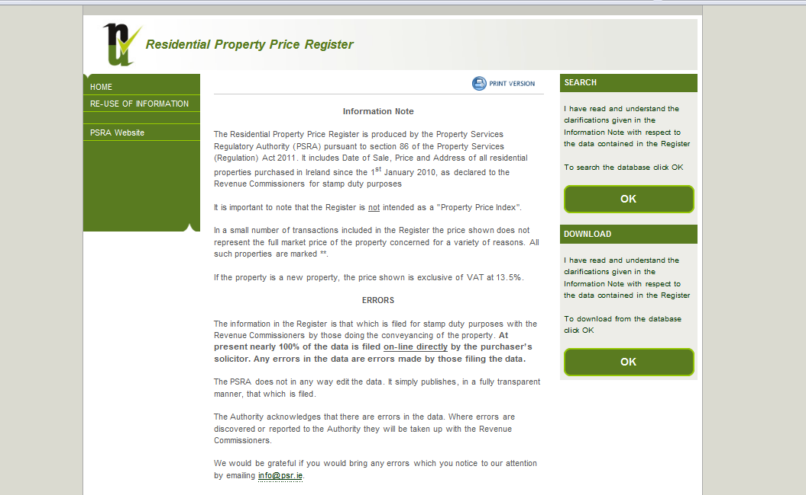

Comments: Contrast between white background and black body text – restrained use of colour – grey and white rollover links – placement of links making navigation easy

4. Research Part C:

Research into type, navigation colour schemes, headers and footers.

Add url of the website here and screen grab
https://sites.google.com/site/cllsamplesite/

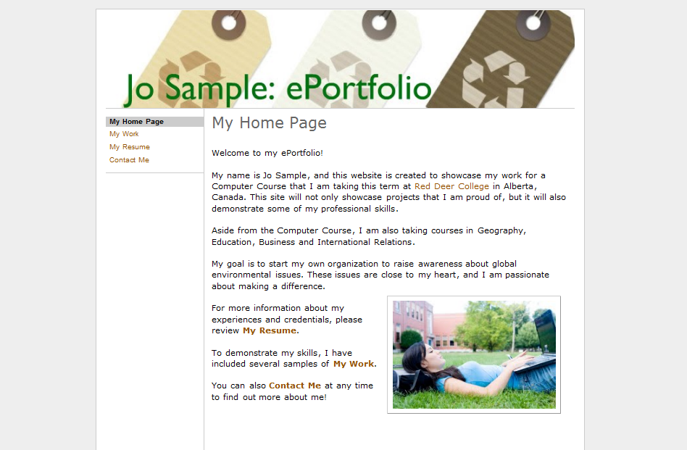

Comments: Research into typefaces for headings in main sections, navigation etc.
Use of header and footer.

5. Preparatory work Part A:
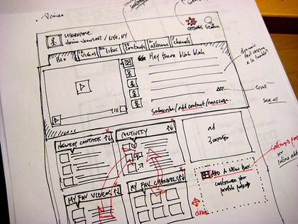

Comments: Home page showing all links and page division – logo placement

6. Preparatory work Part B:
Early Drafts: Early attempts at constructing the site or previewed in a browser
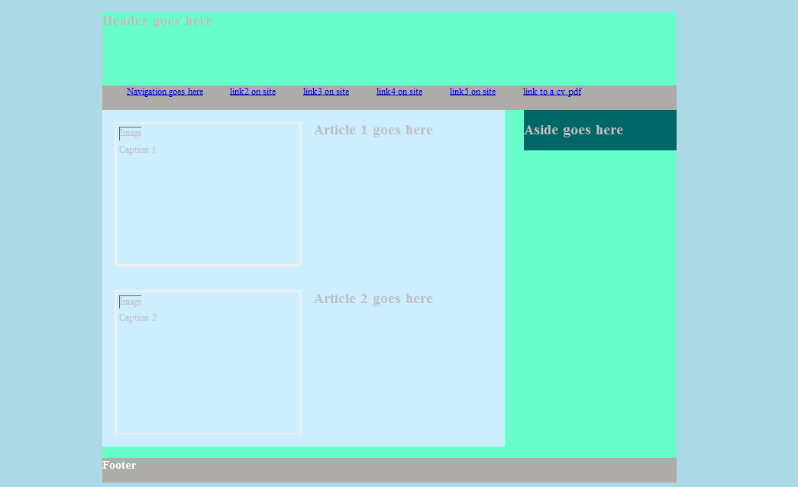

Comments: First draft – not happy with initial colour scheme – changed logo design in final design

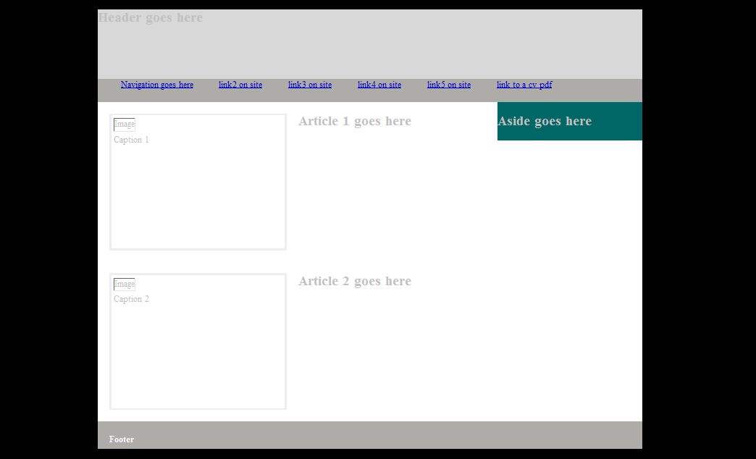

Comments: First draft – not happy with initial colour scheme – changed logo design in final design
7. Finished Website

At least three screen grabs of the finished site

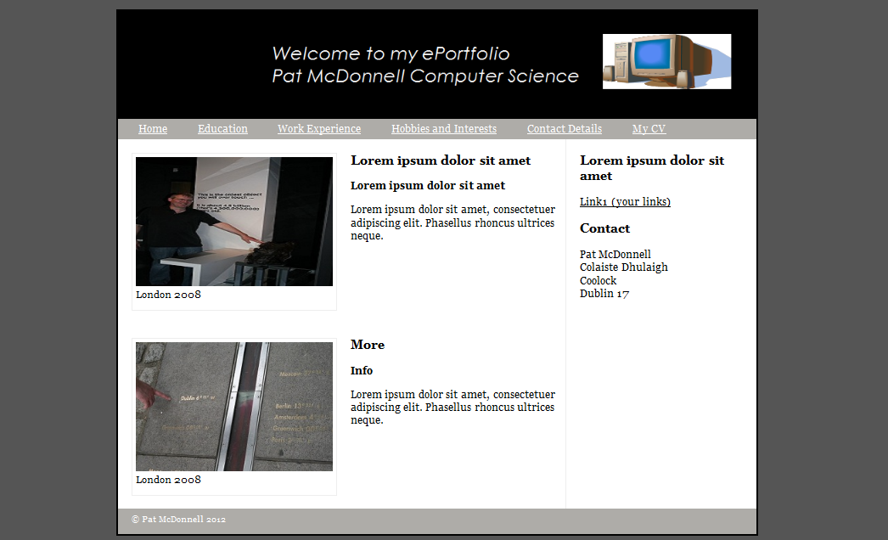

8. Conclusion and Evaluation

An evaluation of the website which should include an investigation of browser compatibility with respect to HTML5 tags.

9. index.html source code

<!DOCTYPE html> <!-- HTML5 -->
<html>
<head>
<title> title goes here</title>
<link rel="stylesheet" href="css/style.css" /> <!-- link to css stylesheet style.css -->
</head>
<body>
<div class="wrapper"> <!-- Wrapper for webpage set at 940px in style.css-->

<header> <!-- start of header -->
<h2> Header goes here </h2>
</header> <!-- /header -->

<nav> <!-- start of navigation -->
<ul>
<li><a href="link.html">Navigation goes here</a></li>
<li><a href="link.html">link2 on site</a></li>
<li><a href="link.html">link3 on site</a></li>
<li><a href="link.html">link4 on site</a></li>
<li><a href="link.html">link5 on site</a></li>
<li><a href="cv.pdf">link to a cv pdf</a></li>
</ul>
</nav> <!--/navigation -->

<section> <!-- start of main page content -->
<article><!-- start of article -->
<figure>
<img src="images/.jpg"/>
<figcaption>Caption 1</figcaption>
</figure>
<h2>Article 1 goes here</h2>
</article> <!--/article -->
<article> <!-- start of article -->
<figure>
<img src="images/.jpg"/>
<figcaption>Caption 2</figcaption>
</figure>
<h2>Article 2 goes here</h2>
</article> <!--/article -->
</section> <!-- /main page content -->

<aside> <!-- start of aside -->
<h2>Aside goes here</h2>

</aside> <!--/aside -->

<footer> <!-- start of footer -->
<h3>Footer</h3>
</footer> <!--/footer -->
</div><!-- /wrapper -->
</body>
</html>

10. style.css source code

